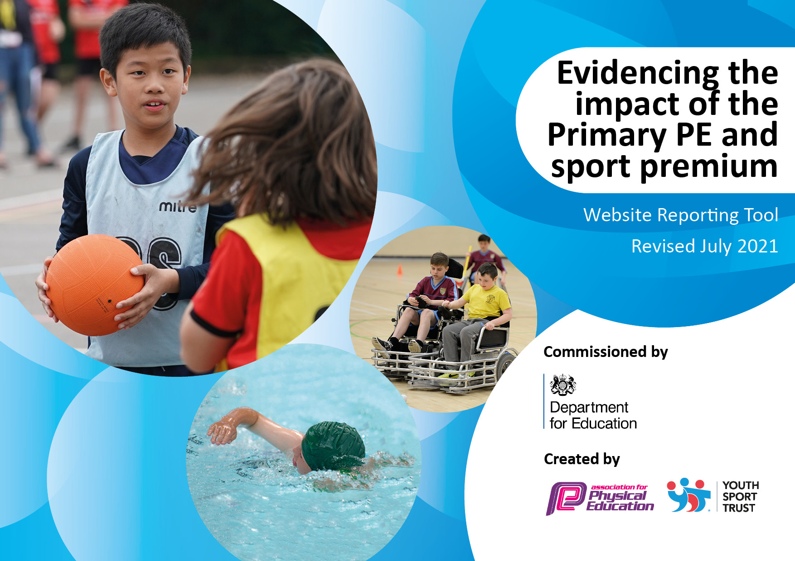

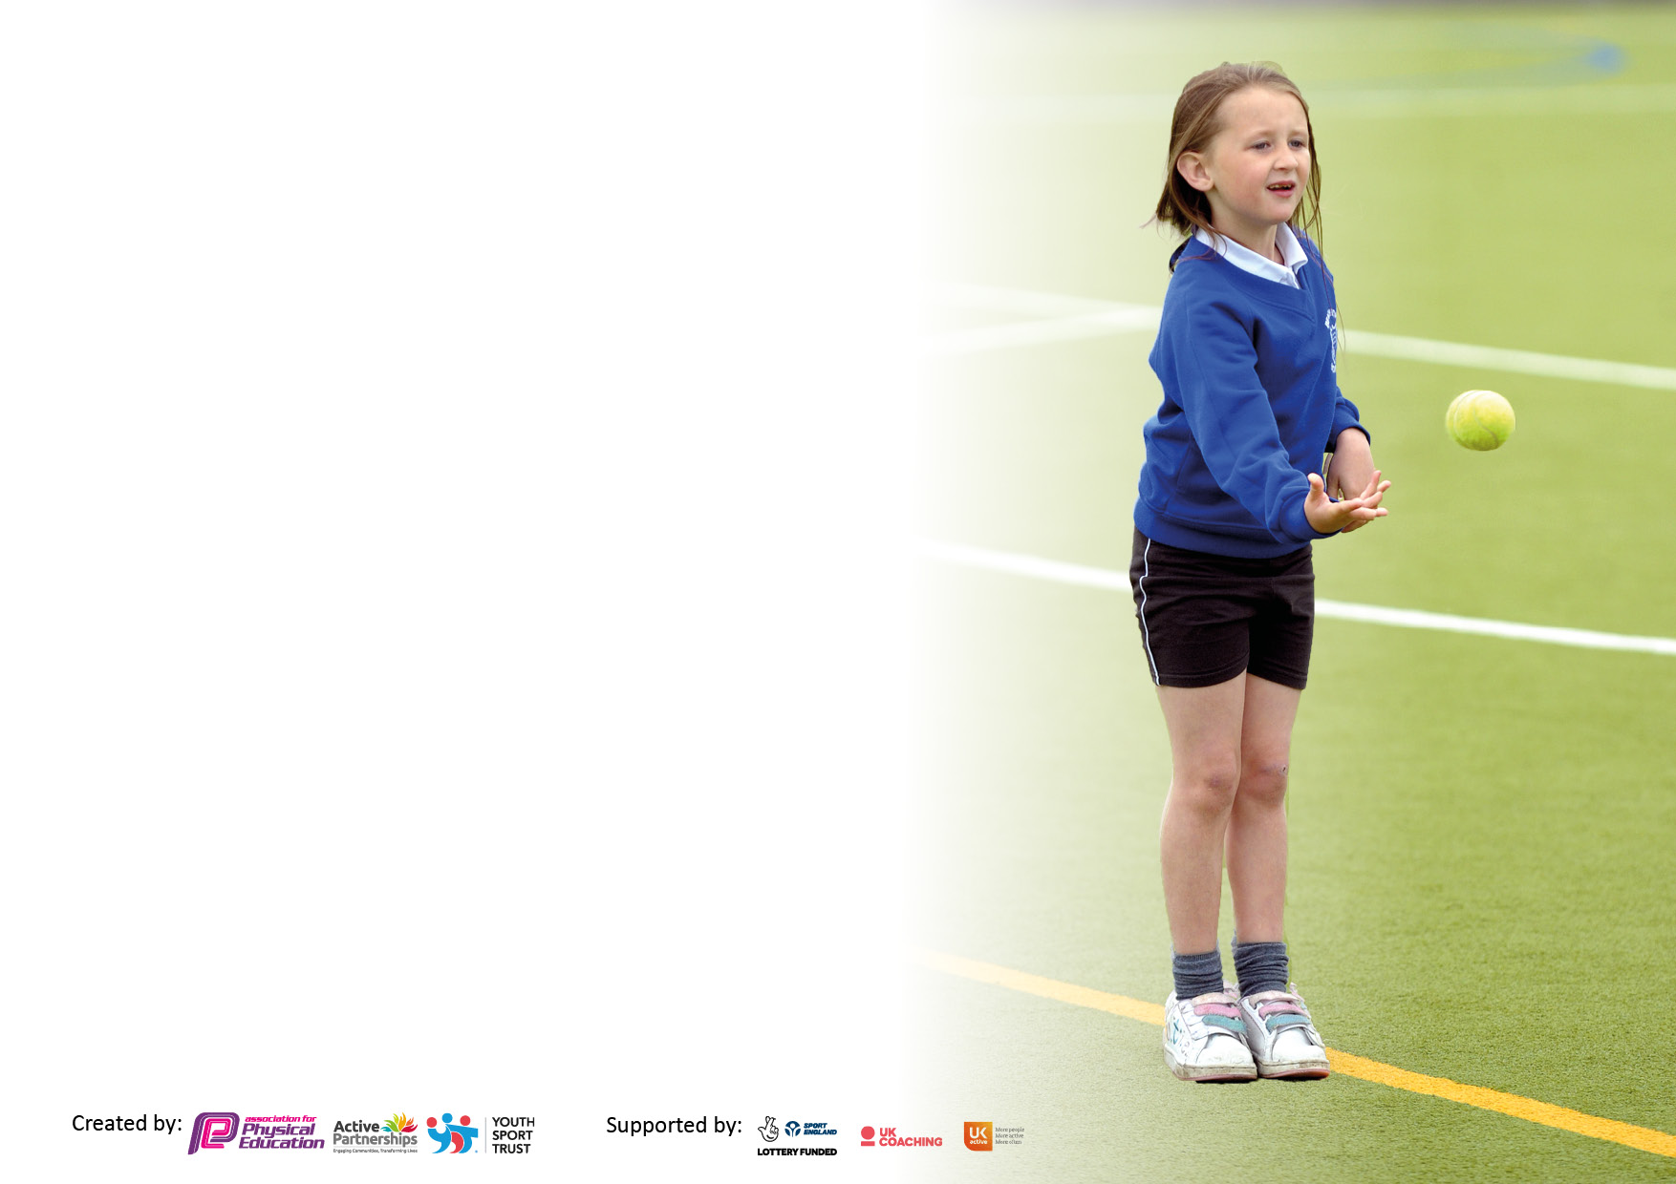

It is important that your grant is used effectively and based on school need. The [Education Inspection Framework](https://assets.publishing.service.gov.uk/government/uploads/system/uploads/attachment_data/file/843108/School_inspection_handbook_-_section_5.pdf) makes clear there will be a focus on **‘whether leaders and those responsible for governors all understand their respective roles and perform these in a way that enhances the effectiveness of the school’**.

Under the [Quality of Education](https://assets.publishing.service.gov.uk/government/uploads/system/uploads/attachment_data/file/843108/School_inspection_handbook_-_section_5.pdf) Ofsted inspectors consider:

**Intent** - Curriculum design, coverage and appropriateness

**Implementation** - Curriculum delivery, Teaching (pedagogy) and Assessment

**Impact** - Attainment and progress

To assist schools with common transferable language this template has been developed to utilise the same three headings which should make your plans easily transferable between working documents.

Schools must use the funding to make **additional and sustainable** improvements to the quality of Physical Education, School Sport and Physical Activity (PESSPA) they offer. This means that you should use the Primary PE and sport premium to:

* Develop or add to the PESSPA activities that your school already offer
* Build capacity and capability within the school to ensure that improvements made now will benefit pupils joining the school in future years
* The Primary PE and sport premium should not be used to fund capital spend projects; the school’s budget should fund these.

Pleasevisit[gov.uk](https://www.gov.uk/guidance/pe-and-sport-premium-for-primary-schools)fortherevisedDfEguidanceincludingthe5keyindicatorsacrosswhichschoolsshoulddemonstrate animprovement.Thisdocumentwillhelpyoutoreviewyourprovisionandtoreportyourspend.DfEencouragesschools to use this template as an effective way of meeting the reporting requirements of the Primary PE and sport premium.

We recommend you start by reflecting on the impact of current provision and reviewing the previous spend.

Schools are required to [publish details](https://www.gov.uk/guidance/what-maintained-schools-must-publish-online#pe-and-sport-premium-for-primary-schools) of how they spend this funding, including any under-spend from 2019/2020, as well as on the impact it has on pupils’ PE and sport participation and attainment. **All funding must be spent by 31st July 2022.**

We recommend regularly updating the table and publishing it on your website throughout the year. This evidences your ongoing self-evaluation of how you are using the funding to secure maximum, sustainable impact. Final copy must be posted on your website by the end of the academic year and no later than the 31st July 2021. To see an example of how to complete the table please click [HERE](http://www.afpe.org.uk/physical-education/wp-content/uploads/afPE-Example-Template-Indicator-2018-Final.pdf).



**Details with regard to funding**

Please complete the table below.

|  |  |
| --- | --- |
| Total amount allocated for 2022/23 | £18570 |

**Swimming Data**

Please report on your Swimming Data below.

|  |  |
| --- | --- |
| Meeting national curriculum requirements for swimming and water safety.  N.B. Complete this section to your best ability. For example you might have practised safe self-rescue techniques on dry land which you can then transfer to the pool when school swimming restarts.  **Due to exceptional circumstances priority should be given to ensuring that pupils can perform safe self rescue even if they do not fully meet the first two requirements of the NC programme of study** |  |
| What percentage of your current Year 6 cohort swim competently, confidently and proficiently over a distance of at least 25 metres?  **N.B.** Even though your pupils may swim in another year please report on their attainment on leaving primary school at the end of the summer term 2020.  Please see note above | 87% |
| What percentage of your current Year 6 cohort use a range of strokes effectively [for example, front crawl, backstroke and breaststroke]?  Please see note above | 80% |
| **What percentage of your current Year 6 cohort perform safe self-rescue in different water-based situations?** | 82% |
| Schools can choose to use the Primary PE and sport premium to provide additional provision for swimming but this must be for activity **over and above** the national curriculum requirements. Have you used it in this way? | No |

**Action Plan and Budget Tracking**

Capture your intended annual spend against the 5 key indicators. Clarify the success criteria and evidence of impact that you intend to measure to evaluate for pupils today and for the future.

|  |  |  |  |  |
| --- | --- | --- | --- | --- |
| **Academic Year:** | **Total fund allocated: £18,570** | **Date Updated: November 2022** | |  |
| **Key indicator 1:** The engagement of all pupils in regular physical activity – Chief Medical Officers guidelines recommend that primary school pupils undertake at least 30 minutes of physical activity a day in school | | | | Percentage of total allocation: |
| 54% |
| **Intent** | **Implementation** | | **Impact** |  |
| Your school focus should be clear what you want the pupils to know and be able to do and about  what they need to learn and to  consolidate through practice: | Make sure your actions to achieve are linked to your intentions: | Funding allocated: | Evidence of impact: | Sustainability and suggested next steps: |
| Ensure children are active for 30 minutes a day.  Increase the amount of participation in sports clubs.  Increase the amount of participation in sports at lunch time. | Work with OPAL to create more purposeful playtimes and use playleaders. (End of the year)  Resources to provide more opportunities for purposeful and active playtimes.  Email teachers links to gonoodle, Zumba kids and Joe wicks to be used as movement breaks within class.  Provide children with a range of sports clubs: netball, football, multiskills, family fitness.  Teach school sport to provide sports for the children at lunchtime three times a week. | £4,969.50  £0  £4,902 | Children have more purposeful playtimes and opportunities to actively play.  Children have movement breaks during the day to ensure at least 30 minutes of activity per day.  There is an increase in the number of pupils attending and engaging with sports clubs. | Continue to provide opportunities for purposeful and active play. Evaluate the impact of OPAL with a final assessment and suggested next steps.  Continue to provide opportunities for children to be active during the day.  Evaluate the amount of children who are participating in sports clubs and continue to look at opportunities to increase the amount of sports children have access to. |
| **Key indicator 2:** The profile of PESSPA being raised across the school as a tool for whole school improvement | | | | Percentage of total allocation: |
| 0% |
| **Intent** | **Implementation** | | **Impact** |  |
| Your school focus should be clear what you want the pupils to know and be able to do and about  what they need to learn and to  consolidate through practice: | Make sure your actions to achieve are linked to your intentions: | Funding allocated: | Evidence of impact | Sustainability and suggested next steps: |
| Celebrate the children’s love of sport on the school display board.  Celebrate pupils sporting achievements in assembly.  Use the school website as a tool to promote sport within school. | Update notice board with pictures of children doing a variety of sports.  Include captions from the children of what they enjoy about sport.  In achievements assembly celebrate the school’s involvement in competitions and leagues.  Update the school page with photos and captions to celebrate the sport being taught in school as well as any inter school competitions. | £0  £0 | During the year the display board has been full of pictures of sport to encourage children to take up a new sport. It has also included children’s work with the commonwealth games.  Certificates were awarded to children who have taken part in competitions which will promote a love of competitive sport.  Inform the wider school of the sports and skills being taught. Raise the profile of PE and competitive sport within the school. | The use of display boards showcasing the achievements of the children in school. Raising the profile within the school without any long term costs.  The publishing of photos and updates of sport within the school will raise the profile of sport within Longlands to the wider community. |

|  |  |  |  |  |
| --- | --- | --- | --- | --- |
| **Key indicator 3:** Increased confidence, knowledge and skills of all staff in teaching PE and sport | | | | Percentage of total allocation: |
|  |
| **Intent** | **Implementation** | | **Impact** |  |
| Your school focus should be clear | Make sure your actions to | Funding | Evidence of Impact | Sustainability and suggested |
| what you want the pupils to know | achieve are linked to your | allocated: |  | next steps: |
| and be able to do and about | intentions: |  |  |  |
| what they need to learn and to |  |  |  |  |
| consolidate through practice: |  |  |  |  |
| Increase the knowledge and skills of all staff in teaching of PE and sport.  Introduce PE assessment to the school. | Teach school sports to provide CPD sessions for teachers to raise the quality of PE taught across the school. 2 Sessions a week spread across the year.  Learning walks by PE lead to ascertain the impact of these sessions and evaluate what the next steps are for the teaching of PE in Longlands.  Have an easy and efficient assessment tool to successfully assess PE within the school. | £3,629  £0 | Teachers can deliver high quality lessons- this has been observed through learning walks.  Teachers have access to high quality lesson plans.  Children have access to high quality PE lessons.  Teachers will have a view of what the children can do which will inform planning. | Staff will be confident in delivering high quality PE lessons. The continuation of CPD will come from sharing good practice within school.  The plans from sessions are available for all teachers to use for future lessons. |
| **Key indicator 4:** Broader experience of a range of sports and activities offered to all pupils | | | | Percentage of total allocation: |
|  |
| **Intent** | **Implementation** | | **Impact** |  |
| Your school focus should be clear | Make sure your actions to | Funding | Evidence of impact: | Sustainability and suggested |
| what you want the pupils to know | achieve are linked to your | allocated: |  | next steps: |
| and be able to do and about | intentions: |  |  |  |
| what they need to learn and to |  |  |  |  |
| consolidate through practice: |  |  |  |  |
| Increase pupils’ enjoyment and engagement of sport. | Review current resources and replace in areas the school is lacking in terms of a rich and broad sports curriculum.  Provide children with the opportunity to learn new sports through Bexley school games festivals. | £4,969.50 | Children have access to a wide range of sports. They are taught PE skills in high quality lessons. | Ensure the effectiveness of all new equipment through audits and learning walks. Equipment to be stored safely and securely to ensure longevity. |

|  |  |  |  |  |
| --- | --- | --- | --- | --- |
| **Key indicator 5:** Increased participation in competitive sport | | | | Percentage of total allocation: |
|  |
| **Intent** | **Implementation** | | **Impact** |  |
| Your school focus should be clear | Make sure your actions to | Funding | Evidence of impact: | Sustainability and suggested |
| what you want the pupils to know | achieve are linked to your | allocated: |  | next steps: |
| and be able to do and about | intentions: |  |  |  |
| what they need to learn and to |  |  |  |  |
| consolidate through practice: |  |  |  |  |
| Increase the amount of competitive opportunities for children in the school.  Increase the amount of inter-house competitions.  Inspire children by providing them the opportunity to meet an athlete. | Keep up to date with competitions available through contact with the Bexley school Games coordinator.  Sign up for a variety Bexley competitions.  Participate in the Bexley football league matches.  PE lead to check the Silver/Gold Award criteria and use this as a guide to make sure the school is participating in as many competitions as is feasible.  Email teachers to encourage them to facilitate class competitions within the sport that they have been learning that term. Subject leader to ask for photos of these competitions and organise certificates for winners.  Contact sports 4 schools to organise a meet the athlete day. | £100  Affiliation Fee (Bexley Football)  £0  £0 | Increase pupils’ access to local competitions.  Increase in the amount of competitions the pupils take part in.  Pupils all have the opportunity to take part in competitive sport within the school.  Pupils will be inspired and be able to ask an athlete how they themselves could become an athlete. | Continue to liaise with Bexley School Games coordinator to participate in competitions.  Review the amount of competitive sport the children are doing in lessons through pupil voice and learning walks.  Find out the impact through pupil voice. |