SCHOOL FUND

School Fund is a voluntary contribution from parents and carers to help finance extras for the children. School budgets are being squeezed more and more every year as the cost of living increases and we are therefore very grateful for any contributions that parents and carers are able to provide. We use these funds to help finance educational workshops, subsidised school visits, end of term treats including but not limited to pantomime/shows and other events during the year, which benefit all of our children.

I would be grateful if you could make a voluntary contribution of £10.00 per child for this academic year. There will be payment items in Parentmail to enable you to contribute what you can or alternatively, any cash contributions can be paid via the school office. Please put any contributions in a sealed envelope titled “School Fund”. All contributions are confidential.

Thank you in advance for your continued support.

Yours sincerely,

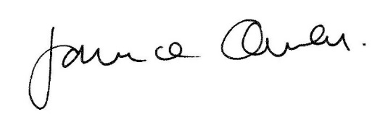

Miss Janice Owen

Head Teacher

